JOMO KENYATTA UNIVERSITY OF AGRICULTURE AND TECHNOLOGY

BSC. COMPUTER SCIENCE

DESIGN AND IMPLEMENTATION OF COMPUTER APPLICATIONS

NOTEBOOK APPLICATION

1. Nixon Gitonga – SCT211-0698/2022
2. Jeddy Awuor -SCT211-0027/2022
3. Natasha Wangui – SCT211-0057/2022
4. Joyjane Githinji – SCT211-0024/2022
5. Christine Nyaga – SCT211-0572/2022
6. Collins Mutugi – SCT211-0051/2022

**INTRODUCTION**

Notebook app is a versatile and user-friendly digital platform designed to improve organization, creativity and productivity. As a virtual notebook, it eliminates the need for traditional handwritten notes by providing users with an easy way to write down thoughts, ideas, and important words. The app has many features that meet the needs of different users and make it useful for students, professionals, and planners.

Users can create multiple notebooks, each with its own meaning or purpose, allowing for productive and engaging content. By supporting texts, images and even drawings, the app encourages creativity and provides a great environment for expressing ideas. With a user-friendly interface, navigating and managing content will be intuitive, providing a seamless and engaging experience.

Collaboration is a key feature of the Notebook application, allowing users to share notebooks with colleagues, friends or peers. Instant synchronization supports seamless integration, ensuring everyone is always aware of the latest updates. The app also includes powerful search capabilities that make it easy to find specific articles or information on important topics.

Whether it's keeping a journal, sketching creative ideas, or keeping a personal inventory, the Notebook app serves as a digital companion to your personal interests and work. Its simplicity, accessibility and integration make it an essential tool for those looking for a modern and effective way to organize and capture their ideas.

This notebook application can be used by the following potential clients:

1. Students: Ideal for taking class notes, organizing study materials, and managing academic information.
2. General Users: Anyone who wants a convenient and organized way to capture and store information for personal use, such as to-do lists, recipes, and personal reflections.
3. Creatives: Beneficial for writers, designers, and artists who need a digital space to jot down ideas, sketch concepts, and keep track of inspiration.
4. Professionals: Useful for business meetings, project management, and general note-taking during work.
5. Researchers: A valuable tool for collecting and organizing research data, references, and findings.

**FUNCTIONAL REQUIREMENTS**

The application is expected to be able to perform the functions listed below:

1. Open 2. Save

1. Undo
2. Cut
3. Copy
4. Paste
5. Find
6. Select all
7. Font
8. Font color
9. Customization
10. Exit
11. User authentication

**NON-FUNCTIONAL REQUIREMENTS**

1. Performance:

- Ensure fast and responsive access to notes.

2. Scalability:

- Handle a growing user and note volume without performance decline.

3. Reliability:

- Maintain high availability and minimize downtime.

4. User Interface (UI) Responsiveness:

- Provide an intuitive and responsive user interface.

5. Compatibility:

- Support popular browsers and devices for broad accessibility.

6. Security:

- Encrypt user data for confidentiality and integrity.

8. Accessibility:

- Design for accessibility, adhering to relevant standards.

10. User Authentication Speed:

- Implement quick and efficient user authentication processes.

11. Data Privacy:

- Comply with data privacy regulations and protect user information.

**SOFTWARE USED**

1. IDE – The application is using Microsoft Visual Studio for development
2. Backend server – The application will use the local server.
3. Database The app will use Microsoft SQL server for its database
4. Version control – the application will utilize GitHub for version control of the system.
5. Documentation – The application will use Microsoft word to keep track of project requirements, design decisions and user guides.

**HARDWARE USED**

1. Development machine – A powerful computer with sufficient RAM and storage is recommended
2. Testing devices – The application will be tested on various desktops and laptops to ensure compatibility

**SCHEDULE**

|  |  |  |
| --- | --- | --- |
| WEEK | ACTIVITY | DELIVERED PRODUCT |
| Week 1 | Writing and submission of Proposal Designing and creation of UI. | Proposal written and submitted |
| Week 2 | Designing and creation of UI | User interface designed and created |
| Week 3 | Creation and implementation of functions | Some functions created and implemented in the application |
| Week 4 | Creation and implementation of more functions. | More functions created and implemented in the application |
| Week 5 | Creation and implementation of database management system | Database management system created and implemented |
| Week 6 | Testing and debugging | Application is tested and debugged. |

FEASIBILITY STUDIES

1. **Economic Feasibility**
   * The notebook requires to run in a computer/desktop that is powerful enough for it which calls for a cost. The software required also needs licenses which may lead to another cost implication.
2. **Schedule Feasibility**

-          The application is to be done in 6 weeks. This will involve the designing, programming and implementation together with testing of the application.

1. **Operational Feasibility**
   * the application is user friendly since it is very easy to understand for the user. it provides a friendly user-interface for creating editing and organizing notes
   * the app also provides security and privacy for the owner.
2. **Technical Feasibility**
   * The application uses Visual studio for development and MS SQL as its database.
   * The application is mainly to run in desktop/laptop computers.
   * The application requires that a powerful enough computer, with sufficient RAM is used to develop and run the program to ensure smooth working of the application

**FLOWCHART**

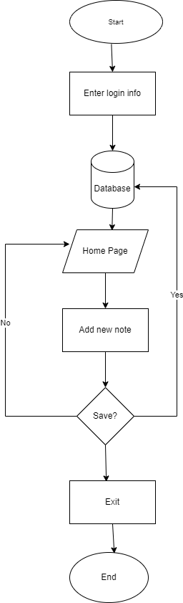

**DATABASE DESIGN**

The purpose of this database design is to support the development of the diary application using SQL.

The application requires the storage of the key entity namely Notes. Each note contains essential information such as Title and Content. Notes serve as the central entity and together with attributes, including NoteID, Title, Content, are clearly defined to represent the application model. This design assumes a basic structure with two tables, one for users and one for storing notes. The notes table has the fields for Title, Content. The user table has fields for username and password together with their attributes.

This proposed database design is well-structured and supports the functionality and scalability of a notebook application. It follows best practices for database design and organizes data effectively, ensuring good performance.

**SEQUENCE DIAGRAM**

User->Notebook App: Launch app

Notebook App->user: Display login page

User->Notebook App: fill sign in details

Notebook App->user: Logs in the user

Notebook App->User: Display main window

User->Notebook App: Click new note button

Notebook App->User: Display note editor window

User->Notebook App: Enter note title and content

Notebook App->User: Auto-save note to local file

User->Notebook App: Click save note button

Notebook App->User: Save note to local file

Notebook App->User: Display confirmation message

User->Notebook App: exit

Notebook->user: exits application

**USER INTERFACE DESIGN**

* Signup page:

Prompts the user to create an account by filling in their details e.g. email address and phone number.

Home page:

Consists of:

A title bar with the user’s name.

Menu bar for easy navigation and access to essential functions.

An area displaying a list of notes with title and the date they were taken.

A button that allows one to add or create a new note.

* Note page:

Allows the user to edit notes and save them.

Support for basic formatting e.g. bold, italics, bullet points.

Settings:

User preferences for themes (light/dark mode), font size, etc.

**PHYSICAL DESIGN**

